Soak Up The Sun – Sheryl Crow - T=120 - Elec Gtr >> Capo2
Intro: Riff
e----------------------|
B-------9--------------|
G-----9---9------------|
D---9-------9-9--7-7---|
A-7---------9-9--7-7---|
E-----------7-7--5-5---| 4x

Si capo2 en acoustic : E>>D – B>>A – A>>G – F#m>>Em – G#m>>F#m -

Verse 1:
E B A E B A
My friend the communist holds meetings in his RV.
E B A E B A
I can't afford his gas, so I'm stuck here watching TV.
1 Riff
E B A E B A
I don't have digital. I don't have diddlysquat.
E B A E B A
It's not having what you want. It's wanting what you've got.

Chorus:
E B F#m
I'm gonna soak up the sun. I'm Gonna tell everyone
G#m A B
To lighten up (I'm gonna tell 'em that)
E B F#m
I've got no one to blame For every time I feel lame
G#m A B
I'm looking up

I'm gonna soak up the sun (1 riff or verse chords)

I'm gonna soak up the sun. (1 riff or verse chords)

Verse 2: (She uses the riff again here, but these are the chords anyways)
E B A E B A
I’ve got a crummy job. It don't pay near enough.
E B A E B A
To buy the things it takes To win me some of your love.

Bridge:
E E/D# D A
Every time I turn around I'm looking up, you're looking down.
E E/D# G A
Maybe something's wrong with you that makes you act the way you do.

Chorus:
E B F#m
I'm gonna soak up the sun. I'm Gonna tell everyone
G#m A B
To lighten up (I'm gonna tell 'em that)
E B F#m
I've got no one to blame For every time I feel lame
G#m A B
I'm looking up

I'm gonna soak up the sun (1 riff or verse chords)
The water's still free (1 riff or verse chords)
I'm gonna soak up the sun (1 riff or verse chords)
before it goes out on me. (1 riff or verse chords)
Verse 3:
E B A E B A
Don’t have no master suite, but I’m still the king of me.
E B A E B A
You have a fancy ride, but baby I’m the one that has the key.

Bridge:
E E/D# D A
Every time I turn around I'm looking up, you're looking down.
E E/D# G A
Maybe something's wrong with you that makes you act the way you do.
G A
Maybe I am crazy too!

Chorus:
E B F#m
I'm gonna soak up the sun. I'm Gonna tell everyone
G#m A B
To lighten up (I'm gonna tell 'em that)
E B F#m
I've got no one to blame For every time I feel lame
G#m A B
I'm looking up

E B F#m
I'm gonna soak up the sun. I'm Gonna tell everyone
G#m A B
To lighten up (I'm gonna tell 'em that)
E B F#m
I've got no one to blame For every time I feel lame
G#m A B
I'm looking up

Outro (only acoustic guitar)
E B F#m
I'm gonna soak up the sun. Got my 45 on
G#m A B
So I can rock on

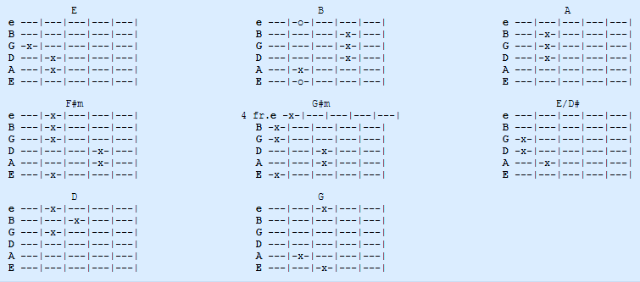
https://www.guitartabs.cc/tabs/s/sheryl_crow/soak_up_the_sun_acoustic_crd_ver_3.html

